A weather report
Now you are the weather presenter. Tell your viewers about today’s weather.
Give them more useful information. Use the helpsheet.

Jetzt bist du der Wettermoderator/die Wettermoderatorin. Informiere deine Zuschauerinnen und Zuschauer über das heutige Wetter. Gib ihnen weitere nützliche Informationen. Nutze die Hilfen auf dem Arbeitsblatt.
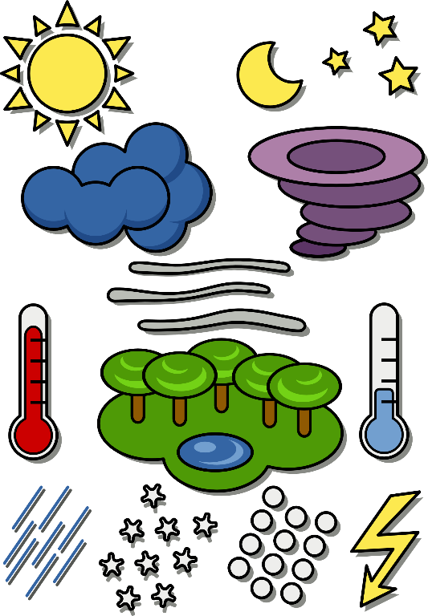

1. Who and where?
Hi there! This is _________________
from _________________
with the weather forecast.
Hello! Welcome to ____________________.

2. The weather
Today it is ____________________.
The weather is ____________________.
It’s ____________________ in ____________________.

3. Extra info
Put on your ____________________.
Don’t forget your ____________________.
wellies • raincoat • umbrella • sunglasses • warm jacket • cap • wooly hat • gloves
Hold on to your ____________________.
So, stay at home!

Now take notes and practice your weather forecast. Present it to the class.
__________________________________________________________________________
__________________________________________________________________________
__________________________________________________________________________
__________________________________________________________________________

Bildquellen:
Icon Sprechen: Flaticon-Lizenz. Verfügbar unter: https://www.flaticon.com/free-icon/lecture_5072

