Beispielaufgaben: Englisch
Kurzbeschreibung
Hinweis: Durch einen Klick auf das Kopfhörersymbol gelangen Sie zu der Audiodatei, die für die Aufgabe genutzt wird.
Anforderungsniveau | Leistungskurs
Themenschwerpunkt | Q2 : Overcoming Prejudice
Überprüfungsformat | Klausur  Aufgaben zum Hörverstehen  +  weitere Teilaufgabe zum Schreiben  (Kommentar zu einem diskontinuierlichen Text (Cartoon)
Details zu den Aufgaben zum Hörverstehen | Task 1: Diversity in Fiction  Kompetenz: Hörverstehen  Hörziele: selektives, detailliertes und inferierendes Hörverstehen  Dauer: 5:17 (3:40 – 8:57)  Quelle: © Vaseem Khan. Verfügbar unter: https://vimeo.com/577549010, Zugriff am 05.06.2023 Weitere Informationen zum Projekt verfügbar unter: https://vaseemkhan.com/diversity-project/, Zugriff am 10.06.2023  BE: 12  Task 2: Interracial Kiss - Star Trek  Kompetenz: Hörverstehen  Hörziele: selektives, detailliertes und inferierendes Hörverstehen  Dauer: 6:00  Quelle: © Player FM, Podcast, 2021. Star Trek breaks a cultural barrier by airing an interracial kiss - November 22nd, 1968. Verfügbar unter: https://player.fm/series/this-day-in-history-class/star-trek-breaks-a-cultural-barrier-by-airing-an-interracial-kiss-november-22nd-1968, Zugriff am: 15.2.2022  Dauer: 6:00  BE: 11  Task 3a): Racism and Mental Health  Kompetenz: Hörverstehen (nur Ton, ohne Bild)  Hörziele: selektives und detailliertes Hörverstehen  Dauer: 4:40 (0:00 – 4:40)  Quelle: Mind, the mental health charity. Tracy Kiryango, 2021. Racism and mental health. Verfügbar unter: https://www.youtube.com/watch?v=crEkQyUDQsw&t=343s, Zugriff am 12.04.2023  BE: 8  oder  Task 3b: Migration Stories (weniger anspruchsvoll)  Kompetenz: Hörverstehen  Hörziele: globales und detailliertes Hörverstehen  Dauer: 3:11  Quelle: Oral History Society. Migration Stories. Verfügbar unter: https://www.ohs.org.uk/for-schools-audio-examples/, Zugriff am 03.05.2023  BE: 6
Hinweise zur Korrektur und Bewertung | Jede sinnvolle Antwort wird akzeptiert. Es werden nur ganze Punkte vergeben. Sollte die Schülerin / der Schüler bei einem Item mehrere Aspekte angeben, so kann der Punkt nur vergeben werden, wenn alle genannten Aspekte inhaltlich richtig sind.  Sprachliche Fehler führen nicht zu Punktabzug, solange die Aussage verständlich ist.  Jede richtig ausgefüllte Lücke in der vorliegenden Klausur ergibt eine BE, ebenso jedes richtig gesetzte Häkchen.
Details zu der weiteren Aufgabe | Kompetenz: Schreiben  Quelle: © Clay Jones, 2014. Shot in Cleveland. Verfügbar unter: https://claytoonz.com/2014/11/28/shot-in-cleveland Zugriff am 19.1.2022
Gewichtung | Hörverstehen: 40% der Gesamtnote  Schreiben: 60% der Gesamtnote

Material für die Schülerinnen und Schüler
Hinweise zur Durchführung
- Für die Bearbeitung der Hörverstehensaufgaben haben Sie ca. 45 Minuten Zeit.
- Sie werden Texte zu drei verschiedenen Aufgaben (tasks) hören. Vor jedem ersten Hören haben Sie jeweils Zeit, sich mit den dazugehörigen Fragen vertraut zu machen.
- Alle Texte, die Sie im Folgenden hören, werden zwei Mal vorgespielt.
- Zwischen den beiden Hördurchgängen haben Sie jeweils Zeit zur Vervollständigung und Korrektur Ihrer Antworten.
- Nach ca. 45 Minuten ist der Prüfungsteil zum Hörverstehen beendet.
- Sie geben Ihre Unterlagen ab und erhalten eine Aufgabe zum Schreiben sowie ein ein- und zweisprachiges Wörterbuch.
- Für die Bearbeitung der Schreibaufgabe haben Sie 90 Minuten Zeit.

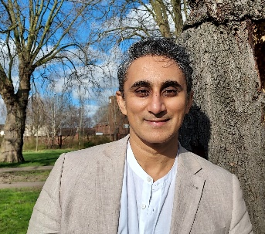
Part 1 – Listening Comprehension

Task 1: Diversity in Fiction (5:10)
Listen twice to Vaseem Khan talking about how to tackle diversity in
writing literature. Complete the table and tick the correct answer.
© Vaseem Khan, 2023

1.1 | what Khan expected from his future as a writer (Name one) (1 P) | - ........................................................................................
1.2 | what makes the last book of his unpublished ones stand out (1 P) | - ........................................................................................
1.3 | his initial misconception of what readers want (1 P) | - ........................................................................................
1.4 | groups that Khan wants to be more diverse in the world of books  (name three) (3 P) | - ........................................................................................  - ........................................................................................  - ........................................................................................
1.5 | what Khan hopes to achieve from diversity in literature (3 P) | - for society: ......................................................................  - for children: ....................................................................  - for books: .......................................................................
1.6 | reasons why book industry needs to diversify  (Name two) (2 P) | - ........................................................................................  - ........................................................................................
1.7 | quote that summarizes Khan’s talk best (1 P) | A | ❒ | Different roads sometimes lead to the same castle. (George R.R. Martin - Writer of Game of Thrones)
 |  | B | ❒ | Diversity is being invited to the party; inclusion is being asked to dance.” (Verna Myers - Vice President of Inclusion Strategy at Netflix)
 |  | C | ❒ | “We all should know that diversity makes for a rich tapestry. (Maya Angelou - AA writer)
____
Task 1: 12 BE
Task 2: Interracial Kiss – Star Trek (6:00)
Listen twice to a history podcast talking about an extraordinary episode of the American TV show Star Trek. Complete the table and tick the correct answer.
2.1 | when this Star Trek episode aired (1 P) | - ........................................................................................
2.2 | what most Americans objected to at the time of the episode’s airing (1 P) | - ........................................................................................
2.3 | advantage of futuristic setting according to Shatner (1 P) | - ........................................................................................
2.4 | what supernatural skill aliens (the ‘Platonians’) have in the episode (1 P) | - ........................................................................................
2.5 | what US Supreme Court decided a year before the Star Trek episode (1 P) | - ........................................................................................
2.6 | why producers filmed a second version of the kiss scene (1 P) | - ........................................................................................
2.7 | why original version of the scene was used in the end (Name two) (1 P) | - ........................................................................................  - ........................................................................................
2.8 | how viewers reacted to the kiss (Name one) (1 P) | - ........................................................................................
2.9 | why interracial kiss was important for some viewers (1 P) | - ........................................................................................
2.10 | how characters in the episode reacted to the kiss  (Name one) (1 P) | - ........................................................................................
2.11 | most suitable title for podcast episode  (1P) | A | ❒ | Star Trek Breaks Cultural Barrier
 |  | B | ❒ | Star Trek Becomes Role Model for Other Shows
 |  | C | ❒ | Star Trek Gains Broader Audience
____
Task 2: 11 BE
Task 3a): Racism and Mental Health (0:00 bis 4:40)
https://www.youtube.com/watch?v=crEkQyUDQsw&t=343s , letzter Zugriff am 12.04.2023. (Diese Tonquelle ist ohne Bild abzuspielen. Bei Position 4:40 ist das Abspielen zu beenden.)

You will hear four people talking about their experiences with discrimination.
Listen to the speakers.
While listening, match two statements (A-J) with each speaker.
There are two extra statements.

Person (in  chronological order) | Solutions | Statements
3.1  Person 1 (Samira) |  | - excelled at school.  - was wrongly accused of misconduct.  - suffered from marital problems.  - tried to change their outward appearance.  - encountered difficulties because of a new law.  - was expelled from school.  - struggled to find suitable professional help.  - is not an American citizen.  - internalized other people’s opinions.  - was involved in political activism.
3.2
Person 2 (Faris)

3.3
Person 3 (Ruth)

3.4
Person 4 (Garrick)

____
Task 3a): 8 BE

OR

Task 3b): Migration Stories (3:08)
https://www.ohs.org.uk/for-schools-audio-examples/ , letzter Zugriff am 03.05.2023.

You will hear three people talking about their experiences as immigrants to the UK.
- Listen to the speakers.
- While listening match two statements (A-H) with each speaker.
- There are two extra statements.

Person (in chronological order) | Solutions | Statements
3.1  Person 1 (Dan) |  | - found acceptance in the community through their new job.  - was astonished by an eating habit.  - struggled with the taste of British food.  - was met with interest and fear.  - was initially mistreated by people.  - felt confused by people’s public display of intimacies.  - often hid behind closed doors.  - came to Britain as one of the very early immigrants.
3.2
Person 2 (Sultan)
3.3
Person 3 (Jossett)

____
Task 3b): 6 BE

Gesamtpunktzahl: / 31 (29) BE

This is the end of the listening part.
Part 2 – Schreiben
Task
Comment on the message of the cartoon, reflecting on the problem of systemic racism in US law enforcement that black people experience.

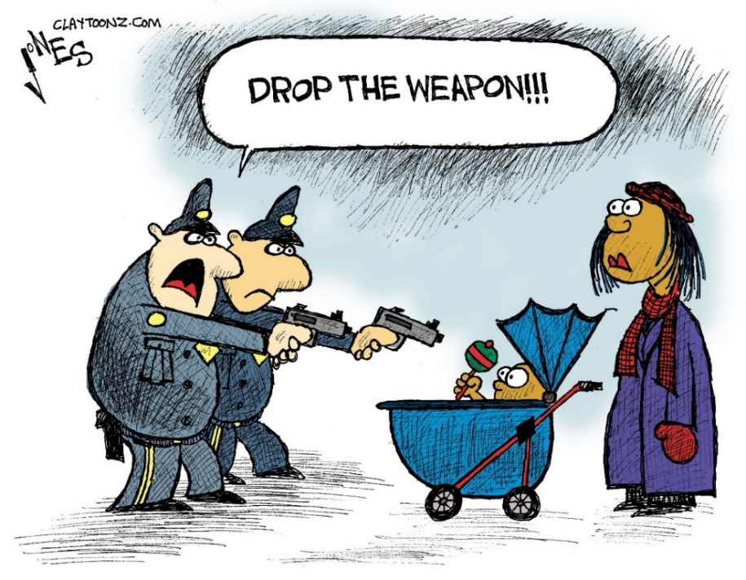

Cartoonist: C. Jones
Source: https://claytoonz.com/2014/11/28/shot-in-cleveland/, Zugriff am 19.01.2022

Hinweis: Notwendigkeit des Streamens
Aus urheberrechtlichen Gründen können die Hördateien zu Aufgabe 3 nicht im MP3-Format zur Verfügung gestellt werden. Sie können die einzelnen Hörtexte jedoch problemlos über den jeweils genannten Link abspielen.

Lösungen und Bewertungen

Die Bewertung erfolgt unter Nutzung des Online-Gutachtens für Klausuren.

Part 1 – Listening Comprehension
Task 1: Diversity in Fiction

1.1 straightforward (writing business) / riches and fame
1.2 Asian character / non-white character
1.3 white characters
1.4 people working in publishing / authors / characters / readers
Es müssen die Aspekte genannt werden, pro Aspekt gibt es einen Punkt.
1.5 for society: overcome barriers / change the world for the better /avoid divisiveness,
for children: see themselves represented /positive reinforcement
for books: more intriguing range
1.6 the world is changing / new generation of readers
1.7 C

Task 2: Interracial Kiss – Star Trek

2.1 late 1960s / November 22nd, 1968
2.2 marriage between black and white people / mixed-race relationships
2.3 focus on social issues (without being direct/obvious)
2.4 telekinetic powers / control Enterprise crew like puppets
2.5 (declared) interracial marriage legal
2.6 to appease the networks / might upset viewers (in Deep South)
2.7 deliberately messed up lines / William crossed his eyes
Beide Antworten müssen gegeben werden, um den Punkt zu bekommen
2.8 few complaints / more fan mail / majority (of letters) (were) positive
2.9 seeing own relationships reflected (on screen) / imagine similar future
2.10 didn’t shock / no comment/discussion
2.11 A
Task 3a: Racism and Mental Health
3.1 D + I
3.2 E + H
3.3 A + B
3.4 C + G

OR

Task 3b: Migration Stories
3.1 D + H
3.2 A + E
3.3 B + F

Bei Nutzung von Aufgabe 3a (31 BE)

Notenpunkte | mindestens zu erreichender Anteil an den insgesamt zu erreichenden Bewertungseinheiten | Anzahl der mindestens zu erreichenden Bewertungseinheiten
15 | 95% | 30
14 | 90% | 28
13 | 85% | 27
12 | 80% | 25
11 | 75% | 24
10 | 70% | 22
9 | 65% | 21
8 | 60% | 19
7 | 55% | 18
6 | 50% | 16
5 | 45% | 14
4 | 40% | 13
3 | 33% | 11
2 | 27% | 9
1 | 20% | 7
0 | 0 | 0

Bei Nutzung von Aufgabe 3b (29 BE)

Notenpunkte | mindestens zu erreichender Anteil an den insgesamt zu erreichenden Bewertungseinheiten | Anzahl der mindestens zu erreichenden Bewertungseinheiten
15 | 95% | 28
14 | 90% | 27
13 | 85% | 25
12 | 80% | 24
11 | 75% | 22
10 | 70% | 21
9 | 65% | 19
8 | 60% | 18
7 | 55% | 16
6 | 50% | 15
5 | 45% | 14
4 | 40% | 12
3 | 33% | 10
2 | 27% | 8
1 | 20% | 6
0 | 0 | 0

Part 2 – Schreiben

Message of cartoon
criticizes, ridicules exaggerated, discriminatory behavior of police officers when faced with (unarmed) black people; underlines systemic racism / racial profiling, a widespread problem, especially in the USA

systemic racism inherent in US law enforcement

- several cases of fatal police shootings of black people that underline how easily black people can become victims of law enforcement (e.g. Breonna Taylor, George Floyd); rate of fatal police shootings among black Americans higher than that for any other ethnicity
- police brutality exemplified in cartoon by policemen aiming at baby with a rattle; in real life: totally unjustified behavior (mistaking toy gun/mobile phone etc. for gun; shooting unarmed black people in back; kneeling on Floyd’s neck for almost 10 minutes etc.)
- racial profiling targeting black people: studies and statistics show for example that they are more likely than whites to be pulled over/ to be searched / to be killed by police / are more likely to receive longer sentences for the same crime than white people
- lack of consequences of violent police behavior: culprits often not found guilty, e.g. Eric Garner’s murderers were not charged, revived BLM movement in 2014
- now seemingly greater awareness of injustice, e.g. after George Floyd’s death: white police officer was sentenced (22 years of imprisonment)
- systemic racism deeply embedded in US society, among other reasons because of past history of discrimination (slavery/Jim Crow laws)
police conduct partly due to

- liberal gun laws, a lot of people carry guns / lack of proper training → increases fear among officers to become victims themselves
- racial bias of white population towards black people leads to unjustified calling of police
- revival of white supremacy
- overfunding of police officers (e.g. military equipment)

possible measures to decrease police violence towards black people
- body cameras
- charging police officers with misconduct, convicting them / not allowing them to stay in the system
- improving training of police officers, e.g. de-escalating, psychological training, police bias training
- ban on chokeholds and strangleholds
- including mental health professionals in response team to help de-escalate situations

