**Cube Buildings**

(LA 1)

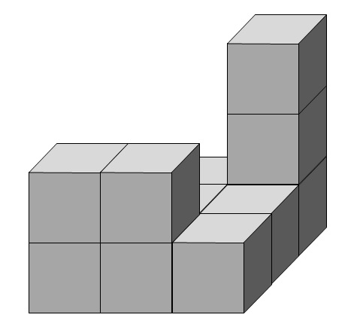

**Table of Contents**

**A Information for Teachers** (with references to the Berlin State Curriculum including tips for language development specifiic to this learning arrangement) **2**

**B Learning Arrangement 9**

**C Worksheets / Materials / Language Support / Answer Keys 10**

**1 The Idea**

|  |
| --- |
| Constructing cube buildings and creating, using and comparing building plans provides many opportunities to develop spatial thinking abilities. By comparing and constrasting two dimensional and three dimensional images of cube building and their relationships to actual structures, the supieriority of building plans, as opposed to pictorial views, can be deduced.  The spatial orientation of the cube buildings is documented by creating building plans. In order to describe these building plans, it is necessary to agree upon a common mathematical vocabulary. These terms and phrases are repeated, broadened and practised throughout the learning arrangement.  Additional activities provide the opportunity to engage in the abstract mode of representation (enactive, iconic, symbolic). This learning arrangement supports the translation between the modes. Pupils grow in their ability to visualise objects and think about them conceptually, which promotes the development of their spatial thinking abilities.  Furthermore, the building of cube structures and the creation of building plans is examined in combination and correlation to one another. The pupils use the „trial and error“ strategy and possibly work through a systematic testing strategy[[1]](#footnote-1) in order to discover how many different cube building can be constructued based on specific criteria.  This learning arrangement teaches and develops the ideas and competencies found in the mathematical themes of the Berlin State Curriculum [L3] Raum und Form (Space and Shape) and [L5] Daten und Zufall (Data and Probability).  **Class 2/3** |

**2 Didatics and Teaching Methods** (practical tips for teachers)

|  |
| --- |
| **Duration:** approx. 3 lessons (45 minutes each)  **Prerequisites:**  The pupils can build cube building from pictorial views. They can read and fill in building plans.  **Introduction:**  The goal of this learning arrangement is to recognize that a building plan clearly provides the most effective construction plan for a cube building. Begin by putting the individual pictures (the architect with the construction drawing, Max the Builder with the completed cube building, [M8](#Bildkarten)) one after the other onto the board and telling the following story: The architect designed and drew a cube building. Max the Builder was given 12 cubes and told to construct the building based on the drawing. However, he’s confused.  Alternatively: The picture ([M1](#Tafelbild)) is displayed on the board (enlarged if on paper or as an image on a Smartboard or interactive white board) without further explanation. The pupils describe what they see in the picture and what they think is happening.  Impulses that could be given by the teacher to spark discussion:   * Why is Max the Builder confused? What’s his problem? * Count the cubes that you can see! * Could the building be constructed using all 12 cubes?   Pupils are then given trays containing cubes (approx. 30 cubes for each pair) which they will use for the following tasks. Each pupils recieves a plan mat ([M2](#Bauflächen)) and is instructed to build the cube building as seen in the construction drawing using 12 cubes. There are two possible solutions: the twelfth cube can either be placed left of the middle cube or in the back left corner. Table partners compare their cube buildings. It is to be expected that some pairs have built different buildings. In the follow-up group discussion, the class should come to the realization that there are two possible ways to construct the building using 12 cubes based on the construction drawing.  Pupils are guided to the conclusion that a construction drawing may not always be the clearest plan to follow when building a structure. They are then challenged to come up ideas to answer: How can we make sure that a building is constructed exactly as the architect planned? How can we make sure that a structure will be built the same every time?  Possible solutions are:   * a second perspective (a view from a different side) * a view from the top * a building plan   The focus of this learning arrangement is on building plans, which pupils should be familiar with from learning arrangement presented in earlier classes. If building plans are not suggested, then the teacher should bring them up.  Each pupil fills in the building plan ([M3](#Bauflächen)) for his/her structure. The two possible building plans for the presented construction drawing are noted on the board and it is pointed out that each building plan is a definitive[[2]](#footnote-2) construction plan for a single building, whereas the drawing allows for two different outcomes. In order to decide which building should be constructed, more information is needed. The pupils will quite probably suggest that the builder call the architect.  **Nr 1.:**  At the end of the first lesson, pupils create their own building plans: partners take turns constructing cube buildings on the plan mats ([M2](#Bauflächen)) and filling in the corresponding building plans ([M3](#Baupläne)). Together they compare and correct the cube buildings and building plans and use the terms printed on the plan mats in their discussions. The filled in building plans are collected by the teacher.  In the subsequent double lesson the pupils practice spatial orientation on a 9 square grid (3x3 plan mat) and then work on Nr 2 and Nr 3.  **Nr 2.:**  The goal of this activity is the development and practice of relevant vocabulary. The teacher acts as a role model and dictates to the class one of the building plans from the introductory lesson using specific phrases related to spatial orientation on the square grids used for building plans. The cube building is built by one pupil in front of the class on a large plan mat ([M6](#große_9er_Baufläche)) using large cubes. At the same time, another pupil fills in the corresponding numbers on a building plan on the board. Mistakes made while building on the plan mat or filling in the building plan should be corrected on the spot.  Then it is a pupil’s turn to be the architect. He/She gives building instructions for cube building which is built in front of the class by another pupil, while a third fills in the corresponding numbers on the building plan on the board. The teacher writes down the important phrases and vocabulary used during this activity and records them on a word wall for future use.  Pairs then recieve building plans from the first lesson and work on completing Nr 2.  After this time of hands-on building in pairs, the class comes together to discuss difficulties that arose while trying to describe how to build the cube building. Any additional vocabulary or phrases presented by the pupils is added to the word wall ([SP](#Sprachspeicher)). For practissing the terms a [matching game](https://learningapps.org/watch?v=pswcmq3ua22)[[3]](#footnote-3) can be used.  **Nr 3.:**  The construction of cube buildings is presented as a combination question. (a question with more than one aspect to consider.) The pupils are challenged to find all the possible cube buildings that can be be constructed based on the given criteria. The building plans are filled in on the worksheet ([AB 1](#AB1)).  More advanced pupils might recognize that the number 10 is broken down into four addends, whereby one addend must be larger than all the other three. Others will solve this task by trial and error.  When finished, the building plans are cut out, checked in pairs for correctness. Doubles are put to the side. Grouping the building plans (for example based on tower height), spurs the pupils to come up with additonal cube buildings that fit the criteria. If needed, the cheat sheet [(M5)](#Tippkarten) can be handed out. The building plans are organised into categories and glued onto a poster. The teacher can give individual pairs the hint to highlight[[4]](#footnote-4)) the common trait in each category. There are 17 possible buildings that could be constructed based on this criteria.  Two pairs compare their posters and explain to each other how they organised the building plans into categories.  **zu 4.:**  This activity refers back to the introduction of the learning arrangement. Pupils fill in building plans based on pictorial views (construction drawings) for which there are different possible cube buildings that can be constructed ([AB 2](#AB2)). Spatial thinking skills are challenged in this task because not all cubes are visible but must still be considered.  It can be helpful to construct the cube buildings on the plan mats ([M2)](#Bauflächen).  Additionally, a interactive [matching game](https://learningapps.org/watch?v=pk0kw8b6c22)[[5]](#footnote-5) can be played to practice matching cube buildings to building plans. |

**3 References to Berlin State Curriculum**

3.1 Process oriented mathematical standards of this learning arrnagement[[6]](#footnote-6)

* Mathematical reasoning: Pupils check mathematical statements for correctness.
* Solve problems mathematically: Pupils work on tasks for which they do not yet have a routine strategy. They develop and use various solution strategies.
* Using mathematical representation: Pupils transfer one representation to another and compare them.
* Communicating mathematically: Pupils describe individual approaches, comprehend solutions of others and jointly reflect solutions. They cooperate to solve tasks together.

3.2. Content-related mathematical competencies of this learning arrangement[[7]](#footnote-7)

|  |  |  |
| --- | --- | --- |
| **Theme** | **Competency** | **Level** |
| **Space and Shape** | The pupil can   * perform movement based on instructions * describe spatial relationships of geometric objects * create specific geometric objects | A  B |
| **Data and Probability** | The pupil can   * systematically work through possibile solutions to combined questions | C |

3.3 Themes and Content of the learning arrangement[[8]](#footnote-8)

|  |  |  |
| --- | --- | --- |
| **Theme** | **Content** | **Level** |
| **Space and Shape** | The pupil   * describes the spatial relation of objects (including using terms such as „to the right of“, „to the left of“) * perfoms movement of objects based on verbal or pictorial instructions * creates building plans of cube structures * constructs cube structures based on building plans and pictoral views | B  C |
| **Data and Probability** | The pupil   * uses the „trial and error“ strategy to solve combined questions | B |

3.4 References to the general curriculum for language development[[9]](#footnote-9)

|  |  |
| --- | --- |
| **Standards of the general language learning curriculum** | The pupil can… |
| **Production/ Speaking** | * describe circumstances and processes * share observations * present results from individual, partner and group work |

3.5 References to the general curriculum for media education[[10]](#footnote-10)

|  |  |
| --- | --- |
| **Standards of the general media education curriculum** | The pupil can … |
| **Presentation** | * present results of individual and group work to an audience |

3.6 References to comprehensive/overarching themes[[11]](#footnote-11)

|  |
| --- |
| * Mobility and Traffic Safety Education (Spatial Orientation) |

3.7 Connections to other subject areas

|  |
| --- |
| * German (Language) |

**4 Language Development**

4.1 Possible language difficulties in task directions

|  |
| --- |
| *Pupils must have an understanding of the following words and phrases:*  *LA:* collect, choose, describe, construct, create, check, sort / sort out, take turns, compare, organise, explain, architect, builder, parts of a building, different, construction drawings |

4.2 Vocabulary list for Comprehension

*The teacher must be sure that the pupils understand the following (mathematical) terms, before they work on the learning arrangement.*

|  |  |  |
| --- | --- | --- |
| **Nouns** | **Verbs** | **Other** |
| cube  cube building  building plan  plan mat  grid  square  corner  doubles  four square grid (2x2)  nine square grid (3x3)  one cube, two cube …tower | design  construct  build  divide  sort  fill in | exactly  taller than/higher than  organise into categories |

4.3 Subject relavent vocabulary and theme specific phrases

During the course of this learning arrangement, the pupils will actively use the following vocabulary and phrases. These will be the foundation for establishing a relevant word list to present their work products.

at the front, in front of, behind, left, right, in the middle, center, to the right/left of

one cube, two cube.... tower

build/construct a one cube, two cube.... tower ....... (for example: in the left front corner)

(for example: in the middle) there is a one cube, two cube.... tower

**5 Material needed for this learning arrangement**

|  |  |
| --- | --- |
| amount | Material |
| per pupil | learning arrangement handout ([L](#LU)A) |
| per pupil | worksheet ([AB 1](#AB1)) |
| per pupil | worksheet ([AB 2](#AB2)) |
| per pupil | 9 square grid/3x3 plan mat ([M2](#Bauflächen)) (possible copied onto thick paper) |
| per pupil | 4 square grid/2x2 plan mat ([M4](#Bauflächen_4)) (possibly copied onto thick paper) |
| per pupil | building plans for Nr 1 ([M3](#Baupläne)) |
|  | cheat sheet ([M5](#Tippkarten)) |
| per pair | poster paper (DIN A3 sheet) |
| per pair | tray to store wooden cubes |
| per pupil | 15 wooden cubes (2 cm square) |
| approx. 15 | large wooden cubes (for example 6 cm square) |
|  | picture ([M1](#Tafelbild)) |
|  | large 9 square grid (3x3 plan mat) ([M6](#große_9er_Baufläche)) |
|  | vocabulary cards for a word wall ([M7](#Wortkarten)) |
|  | pictures for the introduction ([M8](#Bildkarten)), as an alternative to ([M1](#Tafelbild)) |
|  | suggestions for important phrases and vocabulary ([SP](#Sprachspeicher)) |

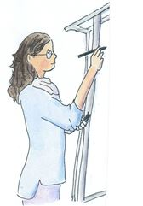

1. Take turns:

Build a cube building on the plan mat ([M2](#Bauflächen)).

Your partner fills in the building plan ([M3](#Baupläne)).

Save all the building plans.

1. Take turns:

Choose a building plan and describe the cube building to your partner.

Your partner should build the building on the plan mat ([M2](#Bauflächen)).

1. Build cube buildings on a four square grid (2x2 plan mat) ([M4](#Bauflächen_4)).

* All the buildings should look different.
* Each cube building is built with exactly 10 cubes.
* There is a cube in every square.
* There is a tower in the back left corner. The tower is taller than all the other parts of the building.

1. Fill in the building plans ([AB 1](#AB1)).
2. How many different buildings are there?
3. Cut out the building plans, check over them and set doubles to the side.

Organise the plans into categories and glue them on a poster.

1. Find another pair. Compare your posters. Explain how you sorted your plans.
2. Fill in different building plans based on the construction drawings ([AB 2](#AB2)).

**Worksheet 1**

Build cube buildings ([M4](#Bauflächen_4)). Fill in building plans.

* Each cube building is built with exactly 10 cubes.
* There is a cube in every square.
* There is a tower in the back left corner. The tower is taller than all the other parts of the building.

|  |  |  |  |  |  |  |  |  |  |  |  |  |  |  |  |  |  |  |  |
| --- | --- | --- | --- | --- | --- | --- | --- | --- | --- | --- | --- | --- | --- | --- | --- | --- | --- | --- | --- |
| |  |  | | --- | --- | |  |  | |  |  | | |  |  | | --- | --- | |  |  | |  |  | | |  |  | | --- | --- | |  |  | |  |  | | |  |  | | --- | --- | |  |  | |  |  | |
|  |  |  |  |
| |  |  | | --- | --- | |  |  | |  |  | | |  |  | | --- | --- | |  |  | |  |  | | |  |  | | --- | --- | |  |  | |  |  | | |  |  | | --- | --- | |  |  | |  |  | |
|  |  |  |  |
| |  |  | | --- | --- | |  |  | |  |  | | |  |  | | --- | --- | |  |  | |  |  | | |  |  | | --- | --- | |  |  | |  |  | | |  |  | | --- | --- | |  |  | |  |  | |
|  |  |  |  |
| |  |  | | --- | --- | |  |  | |  |  | | |  |  | | --- | --- | |  |  | |  |  | | |  |  | | --- | --- | |  |  | |  |  | | |  |  | | --- | --- | |  |  | |  |  | |
|  |  |  |  |
| |  |  | | --- | --- | |  |  | |  |  | | |  |  | | --- | --- | |  |  | |  |  | | |  |  | | --- | --- | |  |  | |  |  | | |  |  | | --- | --- | |  |  | |  |  | |
|  |  |  |  |

**Worksheet 2**

Create different building plans for the pictures. How many are there?

|  |  |  |  |  |  |  |  |  |  |  |  |  |  |  |  |  |  |  |  |  |  |  |  |  |  |  |  |
| --- | --- | --- | --- | --- | --- | --- | --- | --- | --- | --- | --- | --- | --- | --- | --- | --- | --- | --- | --- | --- | --- | --- | --- | --- | --- | --- | --- |
| **1.**  C:\Users\Niedrig\Pictures\würfel_3.JPG   |  |  |  | | --- | --- | --- | |  |  |  | |  |  |  | |  |  |  |  |  |  |  | | --- | --- | --- | |  |  |  | |  |  |  | |  |  |  |  |  |  |  | | --- | --- | --- | |  |  |  | |  |  |  | |  |  |  |   How many different building plans are possible? \_\_\_\_\_ |
| **2.**   |  |  |  | | --- | --- | --- | |  |  |  | |  |  |  | |  |  |  |  |  |  |  | | --- | --- | --- | |  |  |  | |  |  |  | |  |  |  |      |  |  |  | | --- | --- | --- | |  |  |  | |  |  |  | |  |  |  |  |  |  |  | | --- | --- | --- | |  |  |  | |  |  |  | |  |  |  |  |  |  |  | | --- | --- | --- | |  |  |  | |  |  |  | |  |  |  |  |  |  |  | | --- | --- | --- | |  |  |  | |  |  |  | |  |  |  |   How many different building plans are possible? \_\_\_\_\_ |

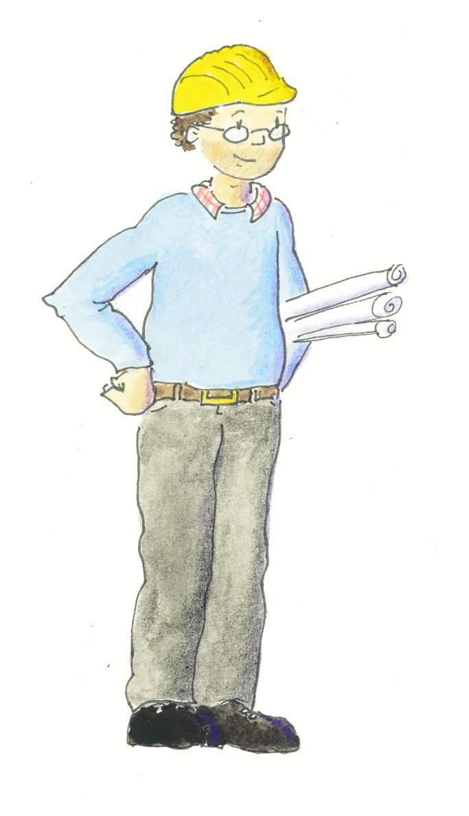Ein Bild, das Text enthält.
Tafelbild (M1)

**?**

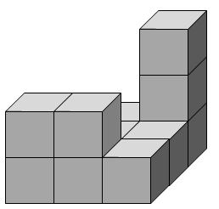

back

✂

|  |  |  |
| --- | --- | --- |
|  |  |  |
|  | in the center |  |
|  |  |  |

left right

front

✂

back

✂

|  |  |  |
| --- | --- | --- |
|  |  |  |
|  | in the  middle |  |
|  |  |  |

left right

front

Plan mats for Task 1:

|  |  |  |
| --- | --- | --- |
|  |  |  |
|  |  |  |
|  |  |  |

✂

|  |  |  |
| --- | --- | --- |
|  |  |  |
|  |  |  |
|  |  |  |

|  |  |  |
| --- | --- | --- |
|  |  |  |
|  |  |  |
|  |  |  |

|  |  |  |
| --- | --- | --- |
|  |  |  |
|  |  |  |
|  |  |  |

|  |  |  |
| --- | --- | --- |
|  |  |  |
|  |  |  |
|  |  |  |

|  |  |  |
| --- | --- | --- |
|  |  |  |
|  |  |  |
|  |  |  |

|  |  |  |
| --- | --- | --- |
|  |  |  |
|  |  |  |
|  |  |  |

|  |  |  |
| --- | --- | --- |
|  |  |  |
|  |  |  |
|  |  |  |

|  |  |  |
| --- | --- | --- |
|  |  |  |
|  |  |  |
|  |  |  |

Plan mats for Task 3:

|  |  |  |  |  |
| --- | --- | --- | --- | --- |
|  |  |  |  |  |
|  |  |  |  |

✂

|  |  |  |  |  |
| --- | --- | --- | --- | --- |
|  |  |  |  |  |
|  |  |  |  |

|  |  |  |  |  |
| --- | --- | --- | --- | --- |
|  |  |  |  |  |
|  |  |  |  |

|  |  |  |  |  |
| --- | --- | --- | --- | --- |
|  |  |  |  |  |
|  |  |  |  |

**Differentiation Help**

Cheat Sheet for Nr 3c

**Tip 1:**

Sort the building plans by the height of the towers.



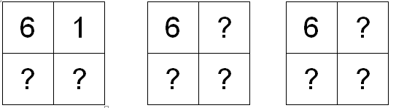

**Tip 2: Six cube Tower**

How can the other cubes be distributed?

**…**



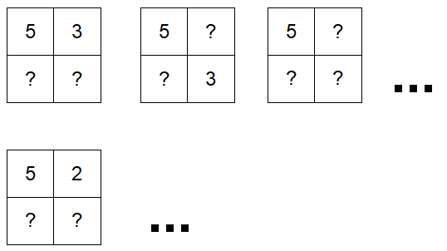

**Tip 3: Five cube Tower** 

How can the other cubes be distributed?

[Matching Game (Building plans) Matching Game (Terms)](https://learningapps.org/watch?v=pswcmq3ua22)

<https://learningapps.org/watch?v=pk0kw8b6c22> <https://learningapps.org/watch?v=pswcmq3ua22>



Plan Mat for large wooden cubes (6 cm square)

|  |  |  |
| --- | --- | --- |
|  |  |  |
|  |  |  |
|  |  |  |

Vocabulary Cards for the Word Wall

|  |
| --- |
| cube building |
|  |
| plan mat |
|  |
| building grid |
|  |
| construction drawing |

|  |
| --- |
| in the middle/ center |
|  |
| behind  at the back  in the back |
|  |
| front  in front of  at the front of |
|  |

|  |  |  |
| --- | --- | --- |
|  | | |
| right  to the right of  on the right side  right front  back right | | |
|  | | |
| left  to the left of  on the left side  left front  back left | | |
|  | | |
| back |  | front | |
|  | | |
| left |  | right | |
|  | | |
| between | | |

|  |  |  |
| --- | --- | --- |
| back left corner | behind | back right corner |
| to the left | in the middle | to the right |
| left front corner | in front of | right front corner |

Pictures for the introductory phases

Amy the Architect



Max the Builder

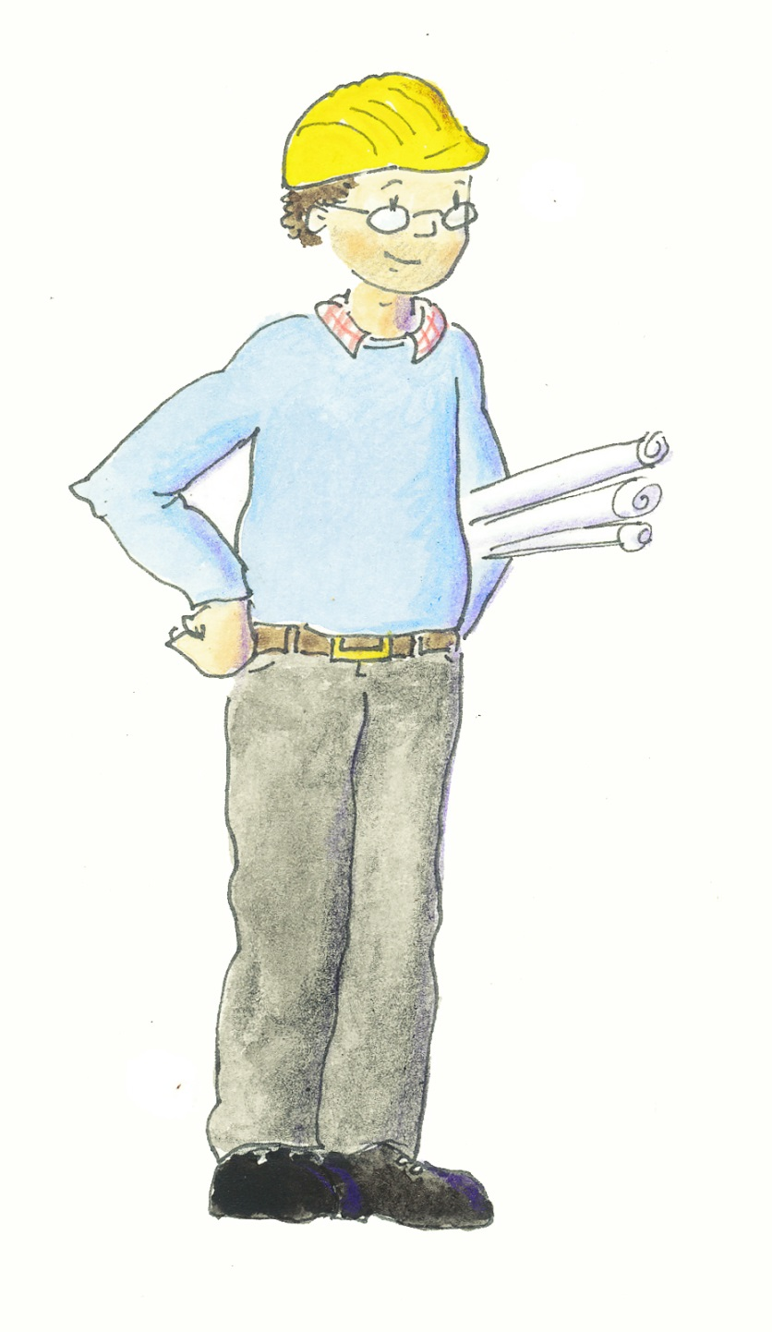

?

Ein Bild, das Text enthält.

Suggestions for the word wall

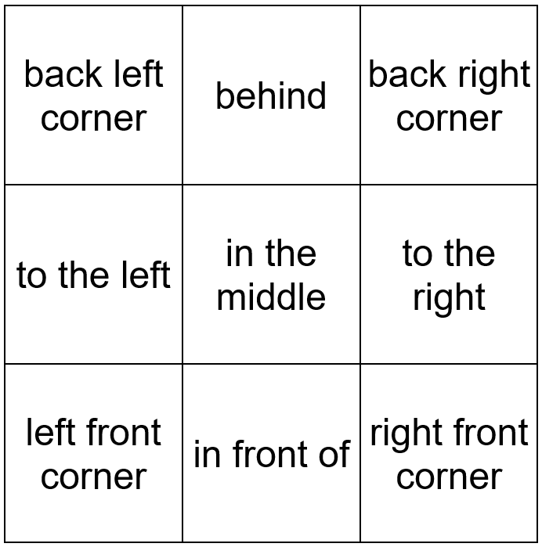

Put a …cube tower in the … .

Build a …cube tower on the … .

In the … there is a …cube tower.

Solutions to the building plans in the introductory phase:

|  |  |  |
| --- | --- | --- |
| 1 | 1 | 3 |
| 0 | 1 | 1 |
| 2 | 2 | 1 |

|  |  |  |
| --- | --- | --- |
| 0 | 1 | 3 |
| 1 | 1 | 1 |
| 2 | 2 | 1 |

Solution to Task 3 (examples of possible placement):

|  |  |  |  |  |  |  |  |  |  |  |
| --- | --- | --- | --- | --- | --- | --- | --- | --- | --- | --- |
| 4 | 1 |  | 5 | 2 |  | 6 | 2 |  | 7 | 1 |
| 3 | 2 | 1 | 2 | 1 | 1 | 1 | 1 |

|  |  |  |  |  |  |  |  |
| --- | --- | --- | --- | --- | --- | --- | --- |
| 4 | 3 |  | 5 | 1 |  | 6 | 1 |
| 2 | 1 | 2 | 2 | 1 | 2 |

|  |  |  |  |  |  |  |  |
| --- | --- | --- | --- | --- | --- | --- | --- |
| 4 | 2 |  | 5 | 2 |  | 6 | 1 |
| 1 | 3 | 2 | 1 | 2 | 1 |

|  |  |  |  |  |
| --- | --- | --- | --- | --- |
| 4 | 1 |  | 5 | 1 |
| 2 | 3 | 3 | 1 |

|  |  |  |  |  |
| --- | --- | --- | --- | --- |
| 4 | 3 |  | 5 | 3 |
| 1 | 2 | 1 | 1 |

|  |  |  |  |  |
| --- | --- | --- | --- | --- |
| 4 | 2 |  | 5 | 1 |
| 3 | 1 | 1 | 3 |

|  |  |
| --- | --- |
| 4 | 2 |
| 2 | 2 |

Solutions for Task 4:

|  |  |  |  |  |  |  |  |  |  |  |  |  |  |  |  |  |  |  |  |  |  |  |  |  |  |  |  |
| --- | --- | --- | --- | --- | --- | --- | --- | --- | --- | --- | --- | --- | --- | --- | --- | --- | --- | --- | --- | --- | --- | --- | --- | --- | --- | --- | --- |
| **1.**  C:\Users\Niedrig\Pictures\würfel_3.JPG   |  |  |  | | --- | --- | --- | | 1 | 0 | 1 | | 1 | 2 | 2 | | 1 | 0 | 1 |  |  |  |  | | --- | --- | --- | | 1 | 1 | 1 | | 1 | 2 | 2 | | 1 | 0 | 1 |  |  |  |  | | --- | --- | --- | |  |  |  | |  |  |  | |  |  |  |   There are two different possible building plans. |
| **2.**   |  |  |  | | --- | --- | --- | | 0 | 0 | 1 | | 2 | 2 | 3 | | 1 | 1 | 1 |  |  |  |  | | --- | --- | --- | | 1 | 1 | 1 | | 2 | 2 | 3 | | 1 | 1 | 1 |  |  |  |  | | --- | --- | --- | | 0 | 1 | 1 | | 2 | 2 | 3 | | 1 | 1 | 1 |  |  |  |  | | --- | --- | --- | |  |  |  | |  |  |  | |  |  |  |  |  |  |  | | --- | --- | --- | |  |  |  | |  |  |  | |  |  |  |  |  |  |  | | --- | --- | --- | | 1 | 0 | 1 | | 2 | 2 | 3 | | 1 | 1 | 1 |   There are four different possible building plans. |

|  |  |  |
| --- | --- | --- |
| Illustrations | page | Sources |
| Symbols for individual, partner and group work | 10 | designed by iMINT Grundschule Mathematik |
| Max the Builder | 12, 21 | drawn by Matthia Lux |
| architect | 9, 20 | drawn by Matthia Lux |
| Cheat sheet symbol (lightbulb) | 16, 17 | free to use  <https://pixabay.com/de/idee-licht-gl%C3%BChbirne-lampe-birne-153974/> [05.01.2018] |
| other graphics |  | desgined by iMINT Grundschule Mathematik |

1. vgl. Rahmenlehrplan Jahrgangsstufen 1-10, Teil C Mathematik, S. 59, Berlin, Potsdam 2015 [↑](#footnote-ref-1)
2. It is definitive because each building plan corresponds to only one building and each building to a specific building plan. [↑](#footnote-ref-2)
3. <https://learningapps.org/watch?v=pswcmq3ua22>. Use the [QR-Code](#QR) to access. [↑](#footnote-ref-3)
4. vgl. <https://pikas-mi.dzlm.de/%C3%BCbergreifendes/aufgaben-adaptieren/forschermittel-verwenden/unterricht>

   [14.02.2019] [↑](#footnote-ref-4)
5. <https://learningapps.org/watch?v=pk0kw8b6c22> Use the [QR-Code](#QR) to access. [↑](#footnote-ref-5)
6. vgl. Rahmenlehrplan Jahrgangsstufen 1-10, Teil C Mathematik, S. 19-21, Berlin, Potsdam 2015 [↑](#footnote-ref-6)
7. vgl. Rahmenlehrplan Jahrgangsstufen 1-10, Teil C Mathematik, S. 22-31, Berlin, Potsdam 2015 [↑](#footnote-ref-7)
8. vgl. Rahmenlehrplan Jahrgangsstufen 1-10, Teil C Mathematik, S. 31ff, Berlin, Potsdam 2015 [↑](#footnote-ref-8)
9. vgl. Rahmenlehrplan Jahrgangsstufen 1-10, Teil B Fachübergreifende Kompetenzentwicklung, S. 6-10, Berlin, Potsdam 2015 [↑](#footnote-ref-9)
10. vgl. Rahmenlehrplan Jahrgangsstufen 1-10, Teil Fachübergreifende Kompetenzentwicklung, S. 15-22, Berlin, Potsdam 2015 [↑](#footnote-ref-10)
11. vgl. Rahmenlehrplan Jahrgangsstufen 1-10, Teil B Fachübergreifende Kompetenzentwicklung, S. 24ff, Berlin, Potsdam 2015 [↑](#footnote-ref-11)