**Isometric Views**

(LU 5)

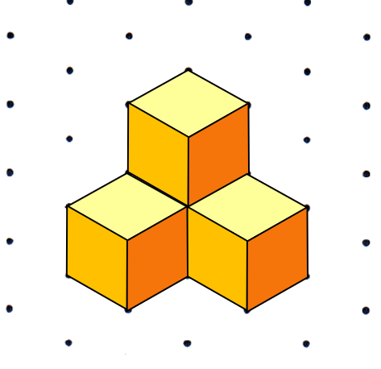

**Table of Contents**

**A Information for Teachers** (with references to the Berlin State Curriculum

including tips for language development specific to this learning arrangement) **2**

**B Learning Arrangement 9**

**C Materials / Language Support / Answer Key 10**

**1 The Idea**

|  |
| --- |
| The development of spatial thinking is a main target of primary school mathematical instruction. Basic geometric vocabulary, such as edges and vertices, as well as the deduction of geometric properties of solids are continually connected to visual representations, making geometry come alive.  Learning to make isometric drawings of cube buildings helps cultivate development in spatial thinking abilities. Therefore, the focus of this learning arrangement is the recognition and production of isometric drawings. Pupils are constantly switching between two-dimensional and three-dimensional images in order to gain confidence in their perception of space. The projection of three-dimensional objects, such as cube buildings, onto another plane is a lengthy learning process. Spatial thinking abilities are particularly important in the planning, drawing and understanding of isometric views because of the necessity to incorporate hidden cubes. This transfer of information from a 3D figure to a 2D picture requires a strong understanding of spatial relations.  The tasks allow pupils the opportunity to work on many different levels of mathematical representation:   * enactive : constructing cube buildings * iconic : producing isometric drawings * symbolic: interpretating building plans (blueprints)   In primary school, graph paper (for cavalier oblique drawings) or dot paper (for isometric drawings) can be used. In this learning arrangement, the focus is on normal isometric views and isometric drawing on dotted paper. The benefit of this technique is that all visible cube faces can be represented by rhombuses of equal size. The isometric views can first be laid with tiles and then drawn. The transfer onto dotted paper is made simple because each rhombus point is always on a dot, allowing for simple outlining or the connection of dots. When using isometric dot paper, distances appear more visually appealing in the drawing because the edges are all the same length (as opposed to cavalier oblique drawings).  This learning arrangement conveys and develops the themes and competencies found in the mathematical themes of the Berlin State Curriculum [L3] *Raum und Form* (Space and Shape).  **Class 5/6** |

**2 Didatics and Teaching Methods** (practical tips for teachers)

|  |
| --- |
| **Duration:** 3 double lessons (90 minutes each)  **Prerequisites:**  Pupils should be familiar with cube buildings and building plans (as presented in LU 1). An understanding of the terms „three cube figure“ and „four cube figure“ is expected. |
| **Introduction:**  Begin by reactivating pupils’ previous knowledge using a large cube. Basic geometric terms should be reviewed as a group and the vocabulary cards displayed on the board (M7). Additionally, the interactive [matching game](https://learningapps.org/watch?v=pkyqcfve322)[1] and interactive m[emory game](https://learningapps.org/watch?v=pv8cr8i2j22)[2] can be played.  Ein Bild, das Tisch enthält.  Automatisch generierte BeschreibungEach pupil gets three rhombuses (M6) to experiment with while attempting to put together an isometric view of a cube. The different possibilities should be presented as a visual on the board using large, magnetic rhombuses and specific attention should be given to the point of view (from above). A pupil points out which faces, edges and vertices of a wooden block are visible in the isometric view.  Before moving on, perspective (from above) and colours (top/light, right/dark) must be agreed upon.  The terms „cube tile“ and „rhombus“ are introduced and the two cube figures are put together using cube tiles.  Explore together the addition of another cube to make a three cube figure (three possible combinations) and use visuals on the board.  Also introduce the isometric dot paper (M1).  In order to further develop the individual spatial thinking abilities of each child, independent work is planned for the following teaching phase. Discussions and collaborations should be encouraged.  **Manipulatives:**  There should be at least ten wooden blocks available for each pupil. Putting together isometric views with manipulatives makes this learning arrangement hands-on. This can be experienced with rhombuses (M5 or M6) and cube tiles (M3 or M4). For some pupils, using cube tiles will be easier than using rhombuses. Providing both manipulatives allows for differentiation in all phases of this learning arrangement, even if not specifically stated in the task instructions. Pupils can decide for themselves which manipulatives they prefer. If needed, a plan mat for the cube buildings can be provided. (M8). Pupils rotate the cube buildings such that the marked corner is always directly in front of them. This makes it easier to draw the isometric view on the dotted paper. Pupils with less developed fine motor skills may benefit from using the larger rhombuses and cube tiles.  **Nr 1.:**  This task refers back to the introduction. The three cube figures should be constructed and then rotated and tilted. The corresponding isometric views are put together with manipulatives and remain laid out on the desks. Pupils will realize that in some isometric views, not all rhombuses are completely visible; some have to be halved (see „Tips and Tricks for laying tiles“, M9). This task requires a lot of time for experimentation. There are eleven possible combinations, but pupils are not expected to discover all of them. Pupils could be encouraged to compare their laid isometric views with those of their classmates. |
| **Nr 2.:**  The four cube figures should be constructed and the isometric views put together with rhombuses on the large isometric dot paper (M1). Outlining the rhombuses makes it easy to produce an isometric drawing. As a means of differentiation, the isometric views can first be laid out with cube tiles and then with rhombuses. Should the spatial perception of individual pupils be highly developed, they could draw the isometric views without the help of laying tiles or outlining. This means that they should draw directly onto isometric dot paper to produce an isometric drawing of the figures.  **Nr 3.:**  Pupils chose one of the four cube figures to draw from different perspectives. This figure should be constructed and then rotated and tilted. Through rotation and tilting, pupils will discover a number of possible orientations. How many they find depends on their ability level and it is not necessary to find all possibilities. Additionally, pupils can put together the isometric views (with rhombuses or cube tiles). The extension to Nr 2 is producing the isometric drawing on smaller isometric dot paper. Should this prove too difficult, then the larger isometric dot paper can continue to be provided.  The teacher should decide whether to do a group reflection session at the conclusion of the first double lesson or begin the second double lesson with it.  Group Reflection: The teacher chooses one pupil to construct a four cube figure and put together or draw the isometric view on the board without the others being able to see their work. In the meantime, the rest of the class also produces an isometric view of the figure individually. Then the answers are compared to the one on the board.  Possible Impulse Questions:   * „How many rhombuses are in the isometric view?“ * „Explain how you got your answer. What was your approach?“ * „How does the isometric view change when I add another cube?“ „How many rhombuses do I need now?“ * „What tips could you give your classmate?“   **Nr 4.:**  The only requirement is to put together an isometric view using exactly 11 rhombuses. Pupils check their work by constructing a partner’s cube building based on the laid rhombuses.  **Nr 5.:**  The challenging part of this task is the production of isometric views of cube buildings, which have been constructed by following specific guidelines for the number of rhombuses and cubes. Spatial thinking skills are particularly needed for this task because of the limited number of solutions (see Answer key). In contrast to Task 5a, not all cubes are visible in the isometric views in Task 5b. Pupils must realize this in order to come up with solutions. A rhombus counts as used even if only half of it is visible in the isometric view.  **Nr 6.:**  Pupils use their imagination to construct cube buildings using a maximum of 12 cubes and then produce isometric drawings. Task cards for independent learning are created by transferring the isometric drawings to the small isometric dot paper and gluing these onto index cards.  **Nr 7.:**  Building plans are converted into isometric views. This task is directed at advanced pupils. It is not intended that the pupils do the hands-on construction of the cube buildings, but the isometric views can be put together and laid with manipulatives.  **Nr 8.:**  There are isometric views of cube buildings that cannot be constructed because of optical illusions: try to find them in this task. The pupils can put together cube buildings and lay them out. They should then draw them. These drawings can be presented in Art lessons.  M. C. Escher is a Dutch graphic artist who is famous for his detailed prints containing amazing optical illusions. He portrays scenes and buildings that appear perfectly logical at first glance, but upon closer inspection, could not exist and would be impossible to build. Books or calendars with works by M.C. Escher could be displayed around the classroom. This learning arrangement offers the chance for cross-curricular projects with Art exploring the works of M. C. Escher or Victor Vasarely. |

**3 References to Berlin State Curriculum**

3.1 Process oriented mathematical standards of this learning arrangement[3]

* Solve problems mathematically: The students work on tasks for which they do not yet have a routine strategy. They develop and use various solution strategies.
* Using mathematical representation: The students transfer one representation to another, change representations purposefully and switch between different representations and levels of representation
* Communicating mathematically: Students cooperate to solve tasks together.

3.2 Content-related mathematical competencies of this learning arrangement [4]

|  |  |
| --- | --- |
| **Theme** | **Compentency** |
| **Space and Shape** | The pupil can depict geometric solids and draw geometric shapes. |

3.3 Themes and Content of the learning arrangement[5]

|  |  |
| --- | --- |
| **Theme** | **Content** |
| **Space and Shape** | The pupil draws isometric views of cubes on isometric dot paper. |

3.4 References to the general curriculum for language development[6]

|  |  |
| --- | --- |
| **Standards of the general language learning curriculum** | The pupil can |
| **Understanding/ Reading comprehension** | * describe and explain graphic representations |
| **production/**  **speaking** | * describe circumstances and processes * share observations * present results from individual, partner and group work |

3.5 References to the general curriculum for media education[7]

|  |  |
| --- | --- |
| **Standards of the general media eduction curriculum** | The pupils can |
| **Presentation** | * design a presentation for learning outcomes that is subject and situation appropriate * present results of individual and group work to an audience |

3.6 References to comprehensive/overarching themes [8]

|  |
| --- |
| * Mobility and Traffic Safety Education *(here: Spatial Orientation)* |

3.7 Connections to other subject areas

|  |
| --- |
| * Art (for example, works by Maurits Cornelis Escher and Victor Vasarely [9]) |

**4 Language Development**

4.1 Possible language difficulties in task directions

|  |
| --- |
| *Pupils must have an understanding of the following words and phrases:*  impossible constructions |

4.2 Vocabulary list for Comprehension

*The teacher must be sure that the pupils understand the following (mathematical) terms, before they work on the learning arrangement.*

|  |  |  |
| --- | --- | --- |
| **Nouns** | **Verbs** | **Other** |
| cube  cube building  two, three and four cube figures  rhombus/rhombuses  cube tile/tiles  isometric view  isometric drawing  isometric dot paper  building plan (blueprint) | put together  lay (laid) | different perspectives |

4.3 Subject relevant vocabulary and theme specific phrases

During the course of this learning arrangement, the pupils will actively use the following vocabulary and phrases. These will be the foundation for establishing a relevant word list to present their work products.

A cube has eight vertices, six faces and twelve edges.

The cube building uses/is constructed using ____ cubes.

The isometric view is made up of ________ rhombuses.

left/right/top surface of the cube

First I laid......, then..... and finally........

The cube is to the right/left of....., behind, on top of, to the back left/right of....

I’m adding ..... rhombuses. If....cubes are added, then ..... more rhombuses are needed .  
This isometric view/drawing is incorrect because this surface is not visible (cannot be seen).

**5 Material for the use of this learning arrangement**

|  |  |
| --- | --- |
| Amount | Material |
| 400 | 2 cm wooden cubes |
| 5 | large wooden cubes (suggested size: 6 cm) |
| per pupil | 12 small cube tiles (M4), preferably copied onto light coloured paper (light yellow) |
| 20 | large cube tiles for the board (M3) (magnetic, if necessary) |
| per pupil | about 15 small rhombuses (M5) each copied onto three different colours of paper (for example light yellow, dark yellow and orange)  for pupils with less developed fine motor skills, 15 large rhombuses (M6) copied onto three different colours of paper (for example light yellow, dark yellow and orange) |
|  | large rhombuses (M6) (magnetic if necessary) |
| per pupil | isometric dot paper M1 or M2 |
| 50 | index cards |
|  | Vocabulary card for the word wall (M7) |
| if needed | plan mat for cube buildings (M8) |

**Isometric Views of** **Cube Buildings**

1. 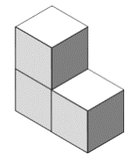Construct the three cube figure.   
   Put together the isometric view with rhombuses or cube tiles.

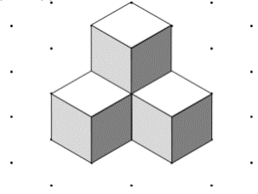Rotate and tilt your figure and lay out other isometric views.   
Compare with a classmate.

1. Construct four cube figures.   
   Put together the isometric views with rhombuses on large isometric dot paper and outline them.
2. Choose one four cube figure and draw it from different perspectives on the small isometric dot paper.
3. Put together an isometric view of a cube building using exactly 11 rhombuses.   
   How many cubes are used to construct your building? _______  
   Let a classmate construct your isometric view with cubes.
4. Now for a challenge:  
   a) Put together an isometric view of a six cube figure using 11 rhombuses.   
   b) Put together an isometric view of a cube building using 14 rhombuses.

The cube building should be constructed using 9 cubes.

1. Construct cube buildings out of a maximum of 12 cubes.  
   a) Draw the building from different perspectives on small isometric dot paper.   
   b) Make task cards.
2. Make isometric drawings corresponding to these building plans.

|  |  |  |  |  |  |  |
| --- | --- | --- | --- | --- | --- | --- |
| 1 | 3 | 3 |  | 2 | 2 | 2 |
| 1 | 3 | 3 |  | 1 | 1 | 2 |
| 1 | 1 | 1 |  | 1 |  |  |

1. Ein Bild, das Baumaterial enthält.

   Automatisch generierte Beschreibung

Are you familiar with the works of M. C. Escher?   
This artist made prints of impossible constructions.  
Use your imagination to design similar structures. Draw and present your creations.

**Isometric dot paper** (large)

**Isometric dot paper** (small)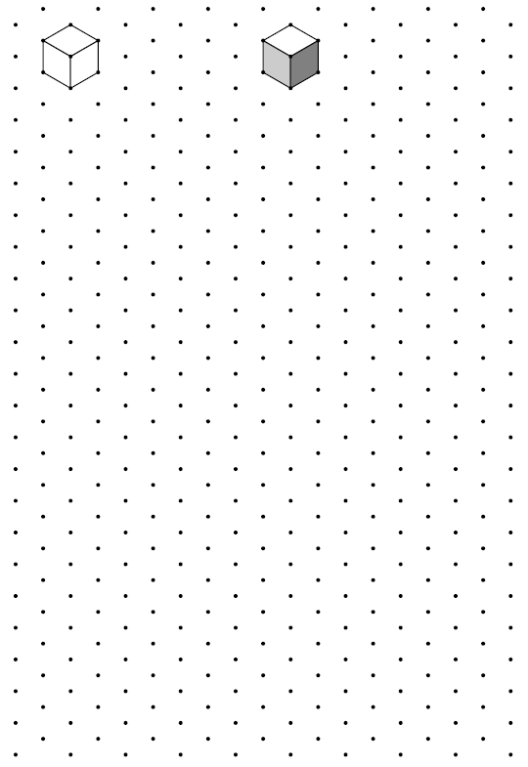

**Large cube til****es** (copy on light coloured paper)

**Small cube tiles** (copy on light coloured paper)

**Small rhombus****es:** copy on three different colours of paper (e.g. light yellow, dark yellow and orange)

**Large rhombuse****s:** copy on three different colours of paper (for example light yellow, dark yellow and orange)

Word Cards for Word Wall

|  |
| --- |
| cube |
|  |
| Ein Bild, das Baumaterial, Ziegelstein, gefliest, Kachel enthält.  Automatisch generierte Beschreibungcube building |
|  |
| plan mat |
|  |
| rhombus |
|  |
| cube tile |

|  |
| --- |
| isometric view |
|  |
| two cube figure |
|  |
| three cube figure |
|  |
| four cube figure |
|  |
| isometric  dot paper |

|  |
| --- |
| face |
|  |
| vertex |
|  |
| edge |

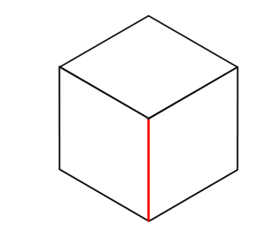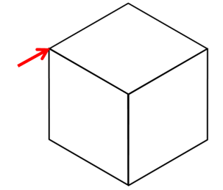

die Ecke

der Würfelvierling

*The terms ca**n be practised with the following interactive games:*

|  |  |  |
| --- | --- | --- |
| **[Matching Game](https://learningapps.org/watch?v=pkyqcfve322)**  <https://learningapps.org/watch?v=pkyqcfve322> | | **[Memory Game](https://learningapps.org/watch?v=pv8cr8i2j22)**  <https://learningapps.org/watch?v=pv8cr8i2j22> |
|  |  | |

Plan mat for cube figures

Differentiation Help

Cheat Sheet

*Only pass out if necessary.*

Ein Bild, das Licht, Silhouette enthält.
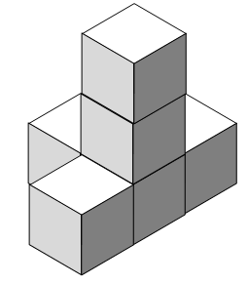

**Tips and tricks for drawing:**

* Lay the rhombuses like this:
* Now trace around them.

**Tips and tricks for putting together and laying:**

The surfaces can look like

this

or like this Example

Ein Bild, das Licht, Silhouette enthält.

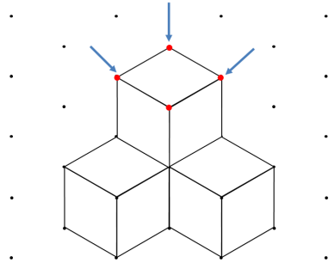

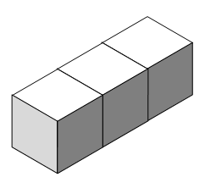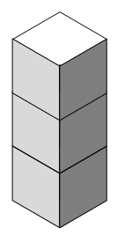Nr 1.:

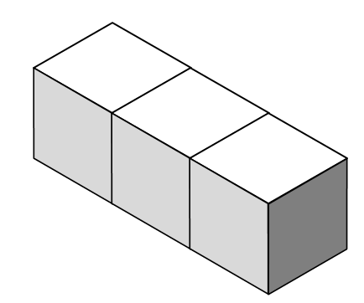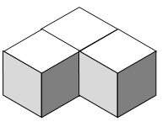

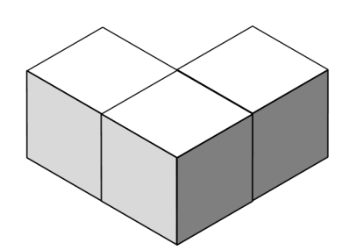

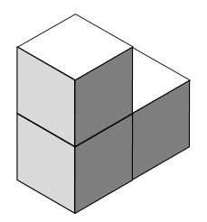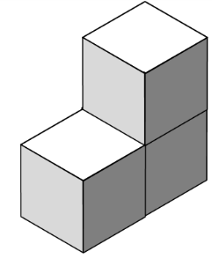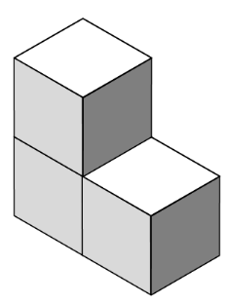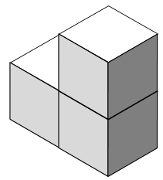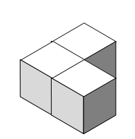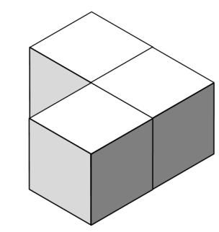

Nr 2./3.: possible solutions (answers will vary)



Nr 4.: possible solutions

6 Würfel 5 Würfel 6 oder 7 Würfel

Nr. 5.: possible solutions

1. b)

Nr. 6.: individual solutions

Nr. 7.: possible solutions

Nr. 8: possible solutions

|  |  |  |
| --- | --- | --- |
| Picture | Page | Source |
| Illustrations |  | produced by iMINT Grundschule Mathematik |
| Symbols for individual, partner and group work | 9 | produced by iMINT Grundschule Mathematik |
| Symbol Cheat Sheet (lightbulb) | 20 | open source (free)  <https://pixabay.com/de/idee-licht-gl%C3%BChbirne-lampe-birne-153974/> [05.01.2018] |

1. <https://learningapps.org/watch?v=pkyqcfve322> Use the QR-Code to access.
2. <https://learningapps.org/watch?v=pv8cr8i2j22> Use the QR-Code to access.
3. vgl. Rahmenlehrplan Jahrgangsstufen 1-10, Teil C Mathematik, S. 19-21, Berlin, Potsdam 2015
4. vgl. Rahmenlehrplan Jahrgangsstufen 1-10, Teil C Mathematik, S. 22-31, Berlin, Potsdam 2015
5. vgl. Rahmenlehrplan Jahrgangsstufen 1-10, Teil C Mathematik, S. 31ff, Berlin, Potsdam 2015
6. vgl. Rahmenlehrplan Jahrgangsstufen 1-10, Teil B Fachübergreifende Kompetenzentwicklung, S. 6-10, Berlin, Potsdam 2015
7. vgl. Rahmenlehrplan Jahrgangsstufen 1-10, Teil Fachübergreifende Kompetenzentwicklung, S. 15-22, Berlin, Potsdam 2015
8. vgl. Rahmenlehrplan Jahrgangsstufen 1-10, Teil B Fachübergreifende Kompetenzentwicklung, S. 24ff, Berlin, Potsdam 2015
9. Poser-Kempe, Katja: Auf den Spuren von Vasarely. Gestalten von Kunstwerken aus Würfelmustern. In: Grundschule Mathematik (2017) 55, S.24-27