Let’s have breakfast!
What can you have for breakfast?
- Write words in the lists.

Was gibt es zum Frühstück?
- Schreibe Wörter in die Listen.
ABC
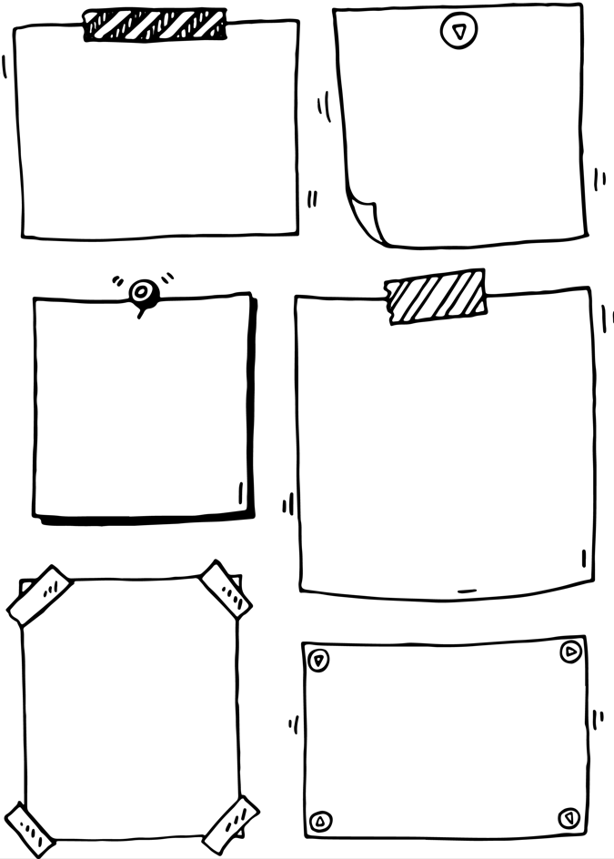

from the bakery
___________________________
___________________________
___________________________

drinks
_________________________
_________________________
_________________________

in a bowl
___________________________________
___________________________________
___________________________________

fruit
____________________
____________________
____________________
____________________

on your toast
_________________________
_________________________
_________________________
_________________________

what else?
___________________________________
___________________________________
___________________________________

Notizzettel: Nikolaeva, Shutterstock.com

