1.
7 Minute Workout Song (w/timer) I Tabata Songs
https://www.youtube.com/watch?v=mmq5zZfmIws

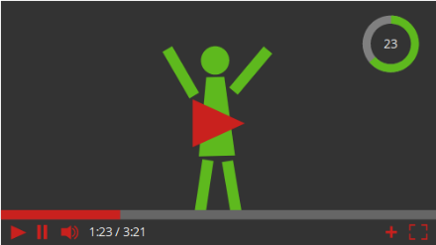
2.
„7 Minute Workout Music & Timer – w/Italo Naibo“
https://www.youtube.com/watch?v=Q_Rox_zOcM4

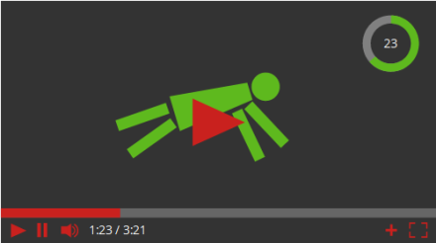
3.
7 Minute Workout Song (ROCKY MIX) w/timer
https://www.youtube.com/watch?v=iGZUw_fn0X0

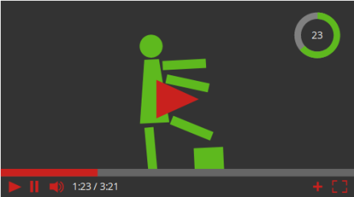

7-Minuten-Training

